Getting Down with the Garage Groove!

Name: Date:

Literacy: (4 – 6 years)

1.

2.

3.

4.

5.

6.

7.

8.

9.

10.

Getting Down with the Garage Groove!

Name: Date:

Maths: (4 – 6 years)

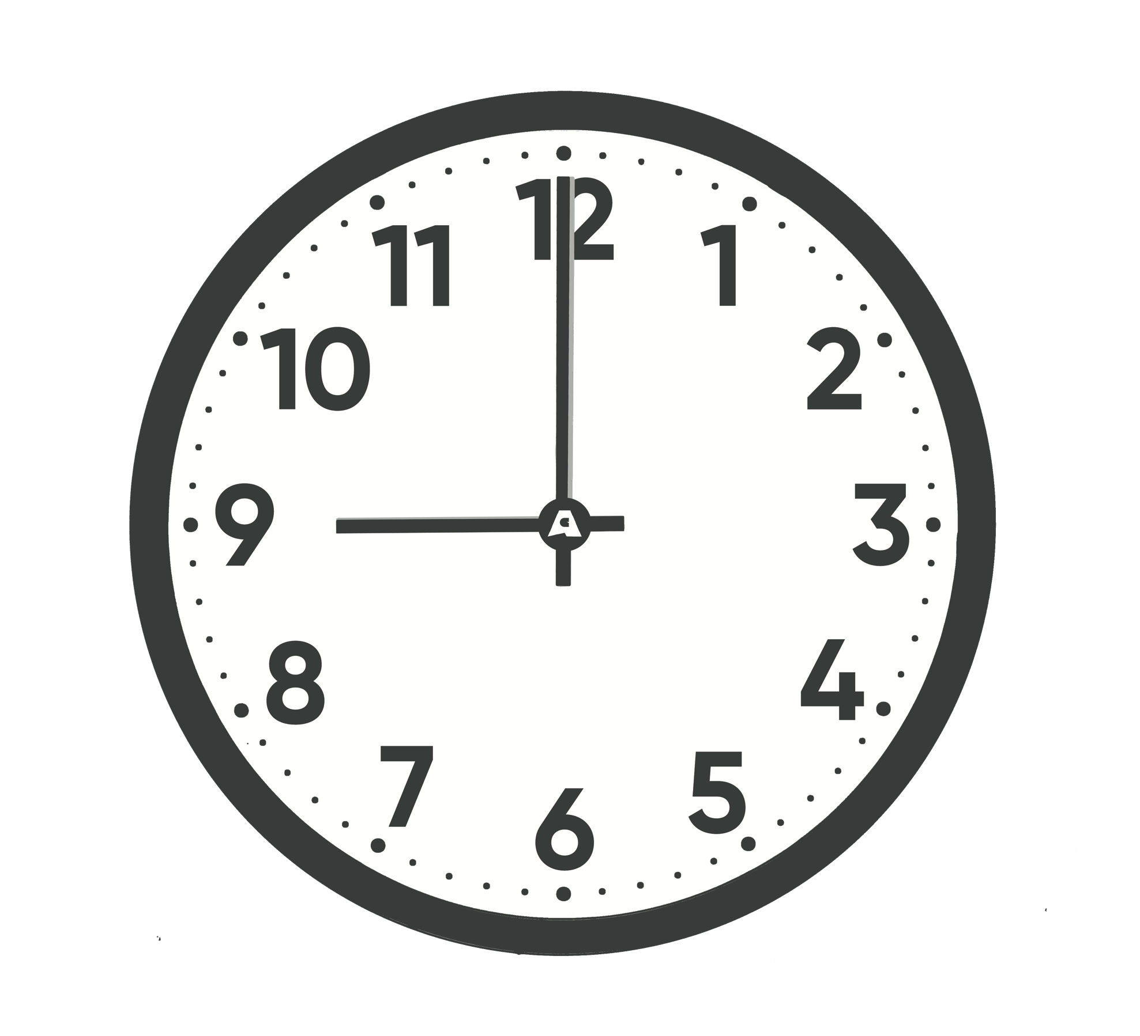  Morning |  | 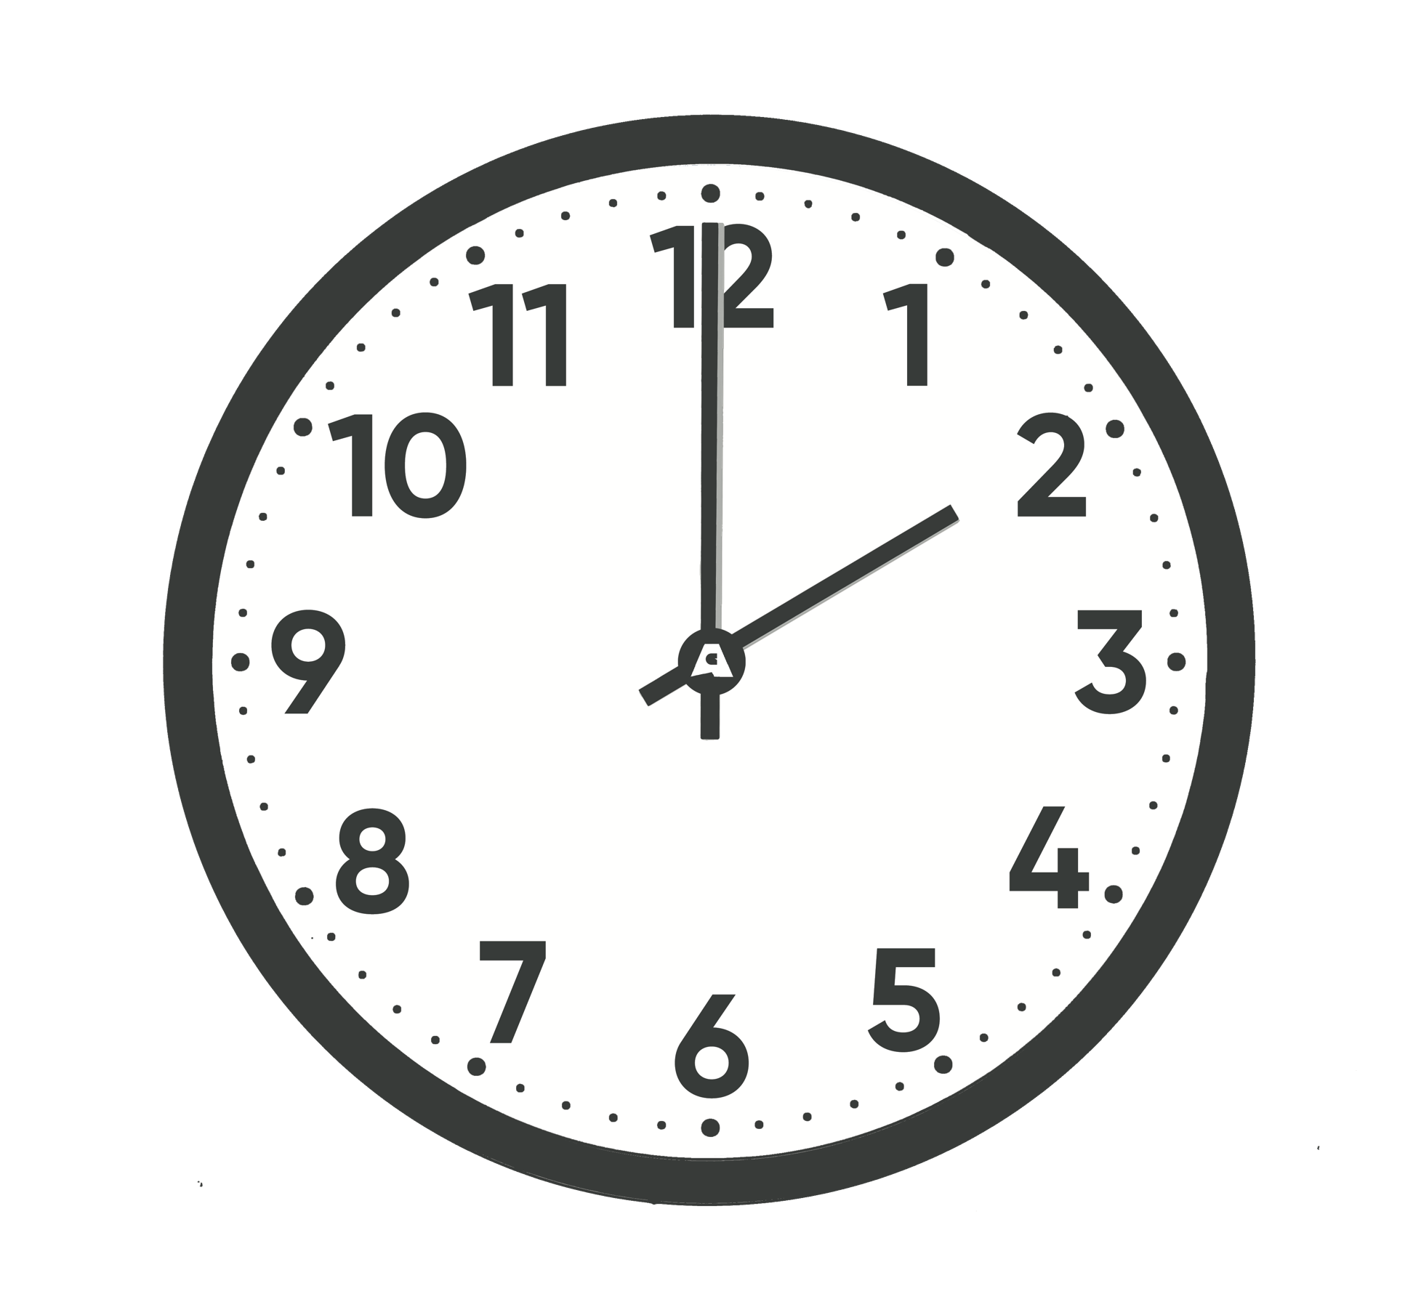  Afternoon
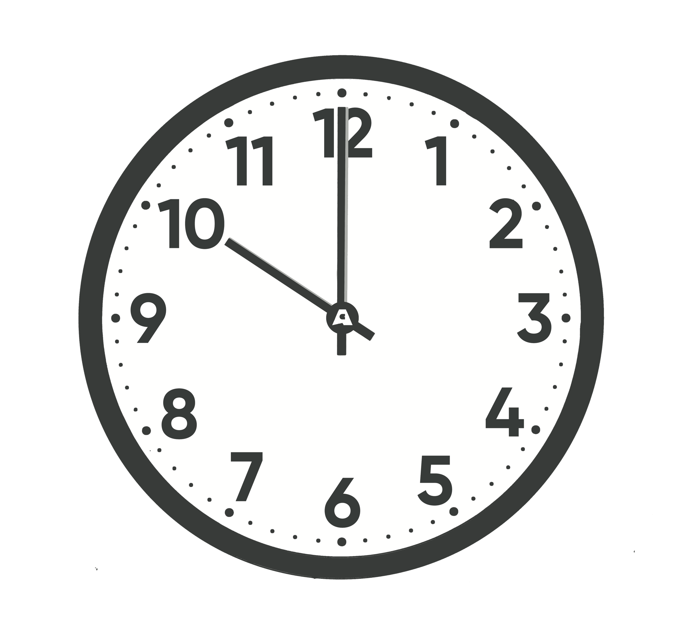  Morning |  | 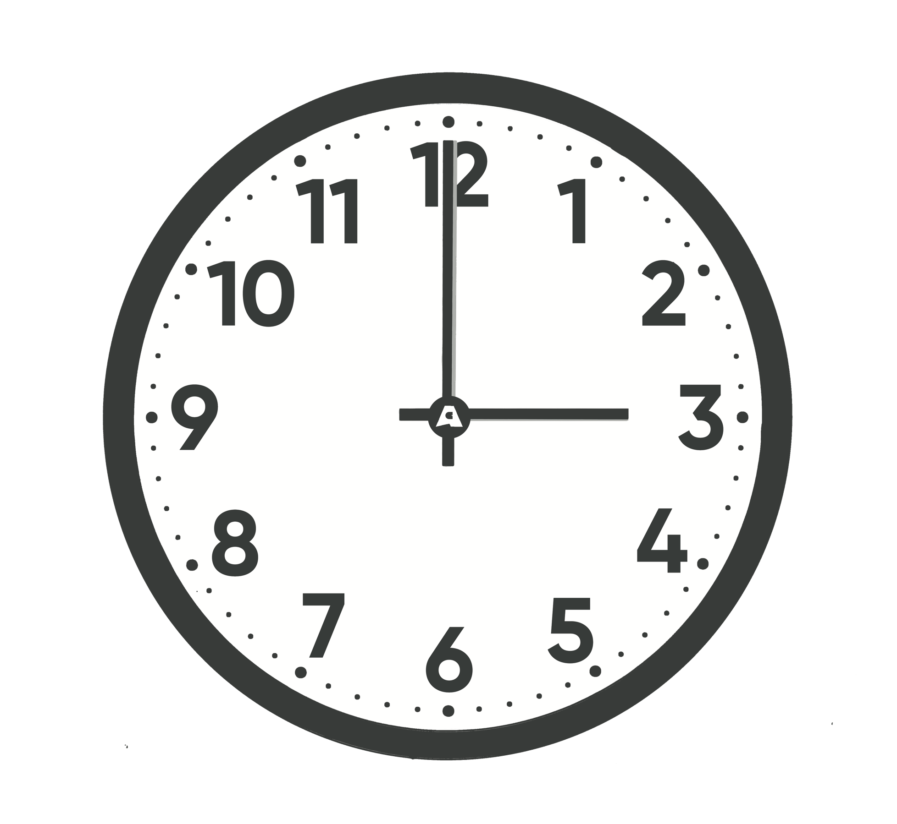  Afternoon
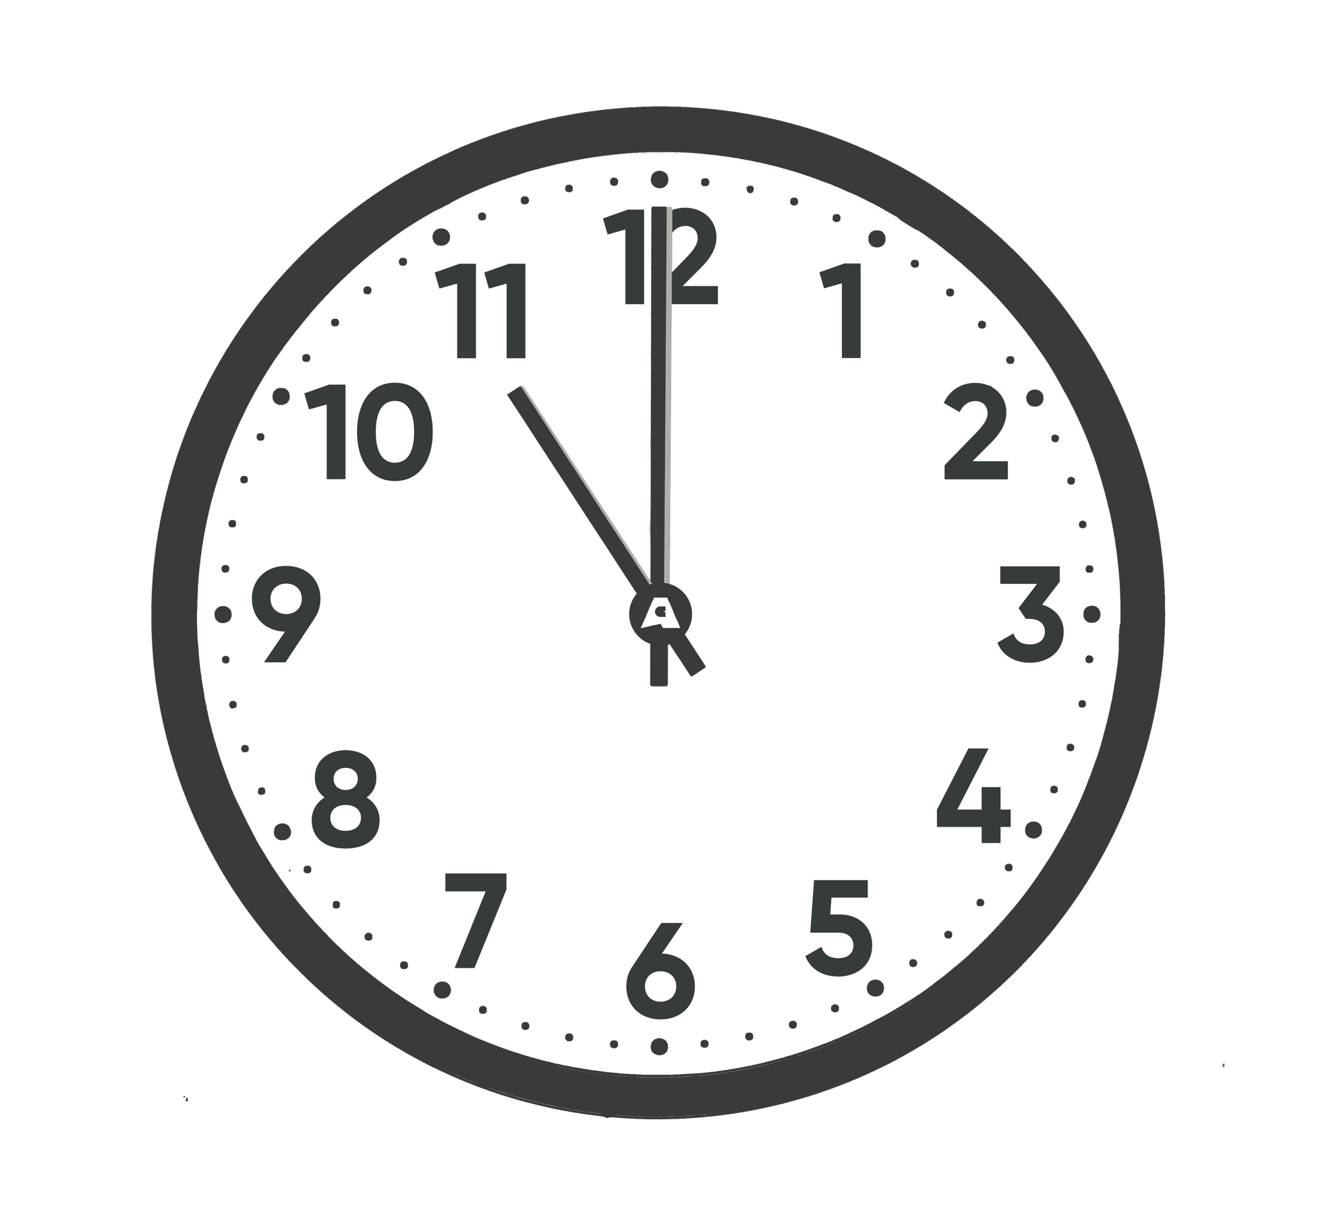  Morning |  | 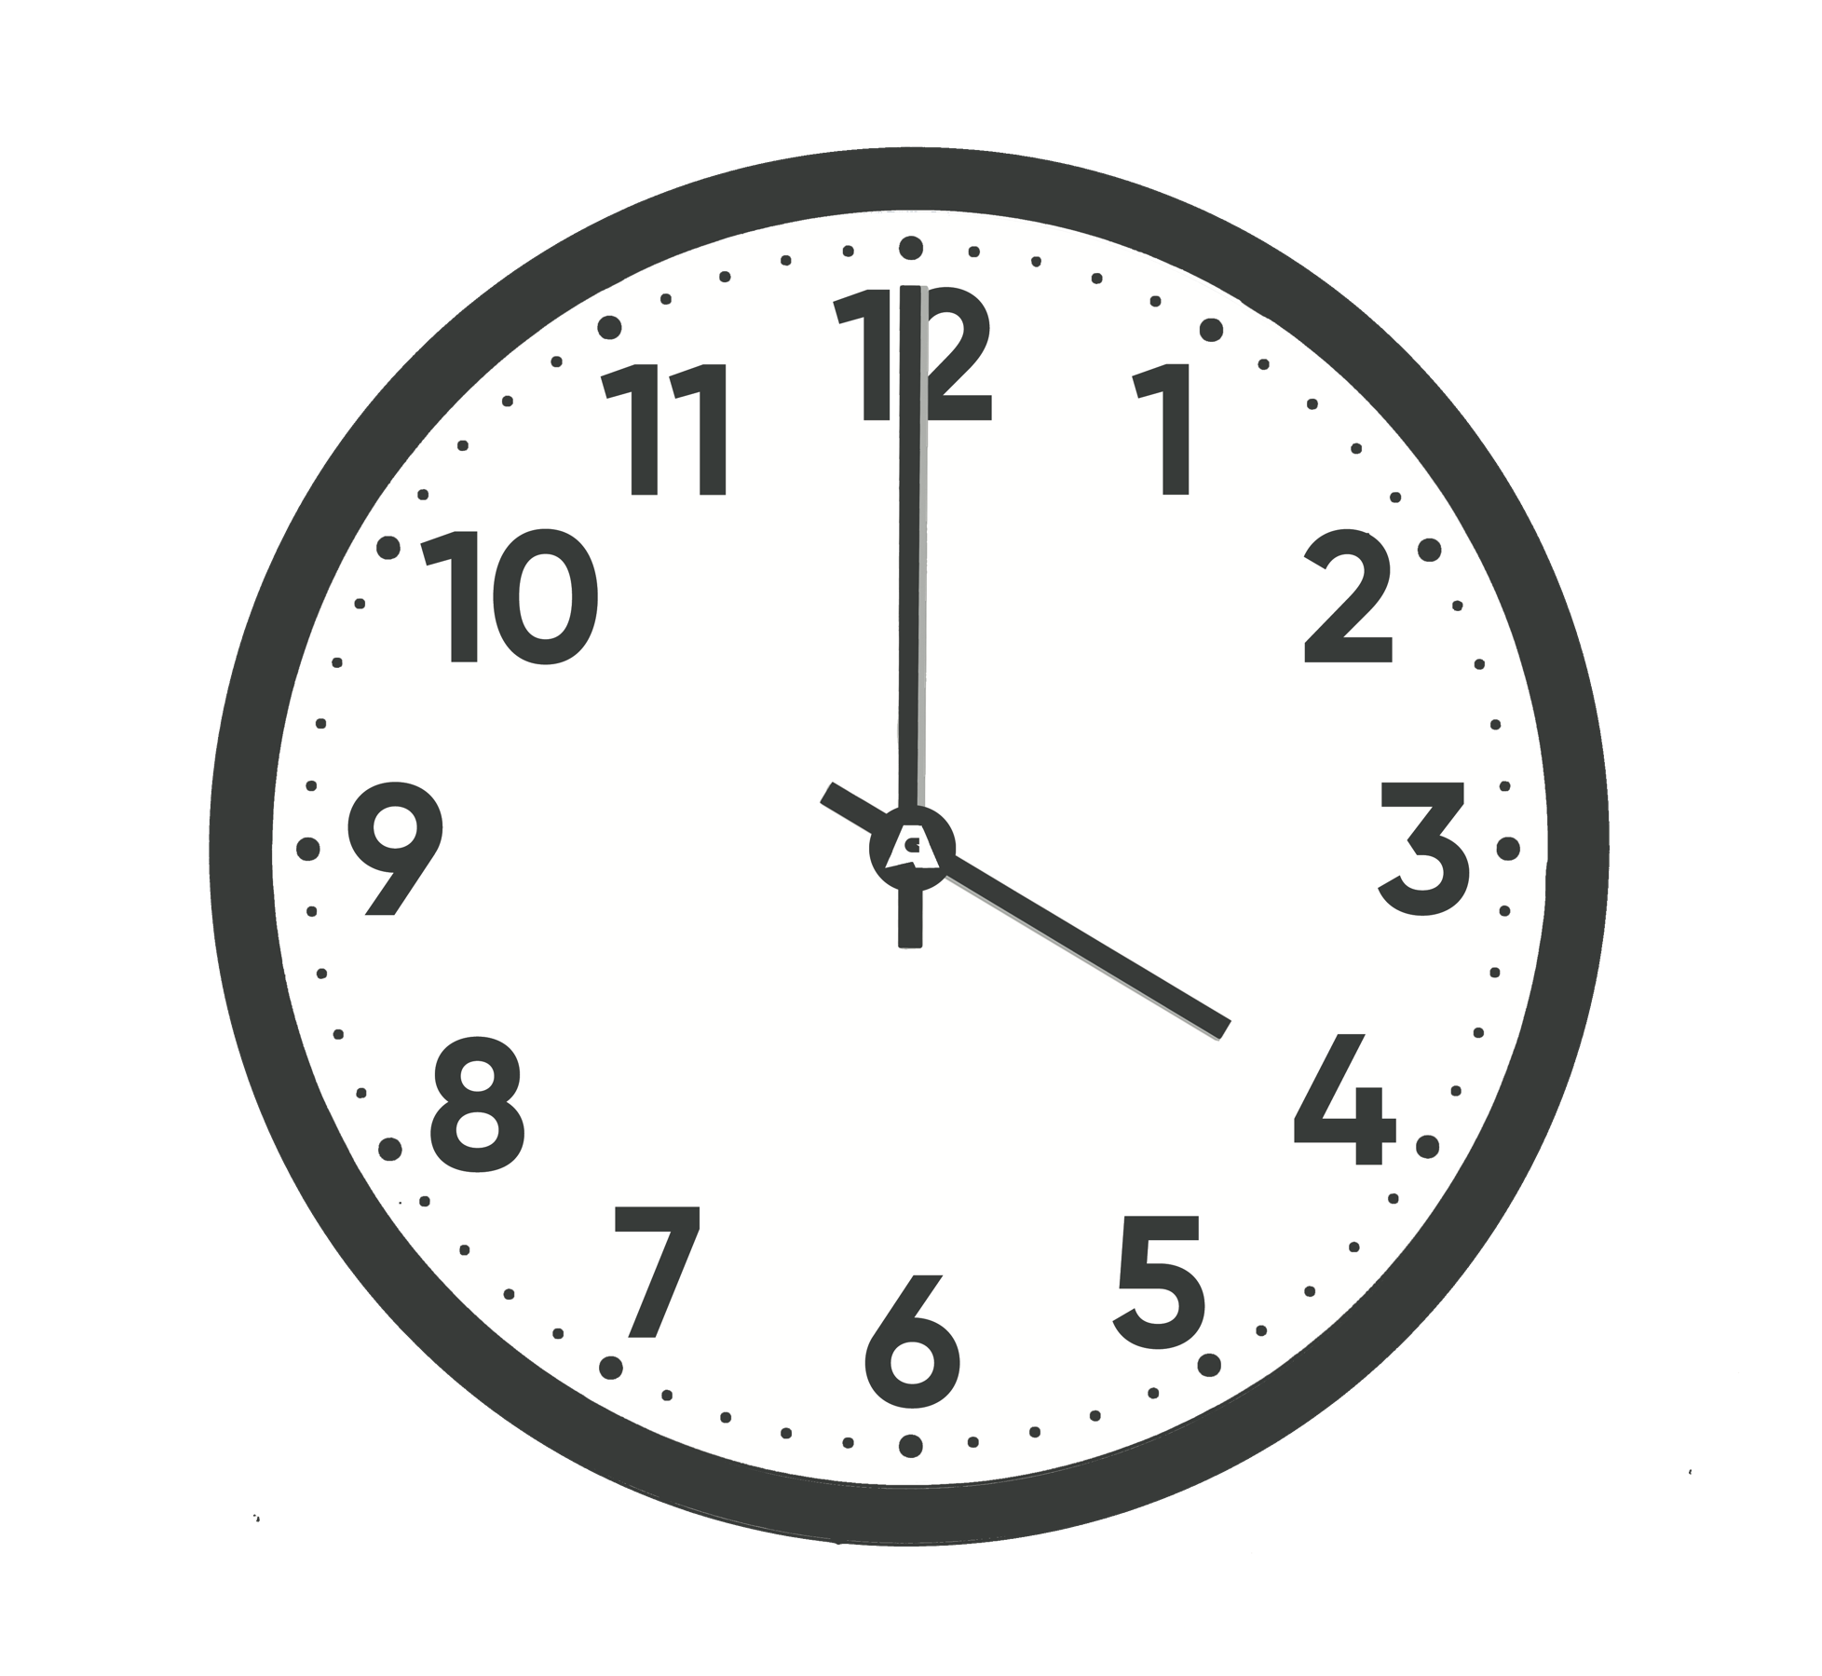  Afternoon
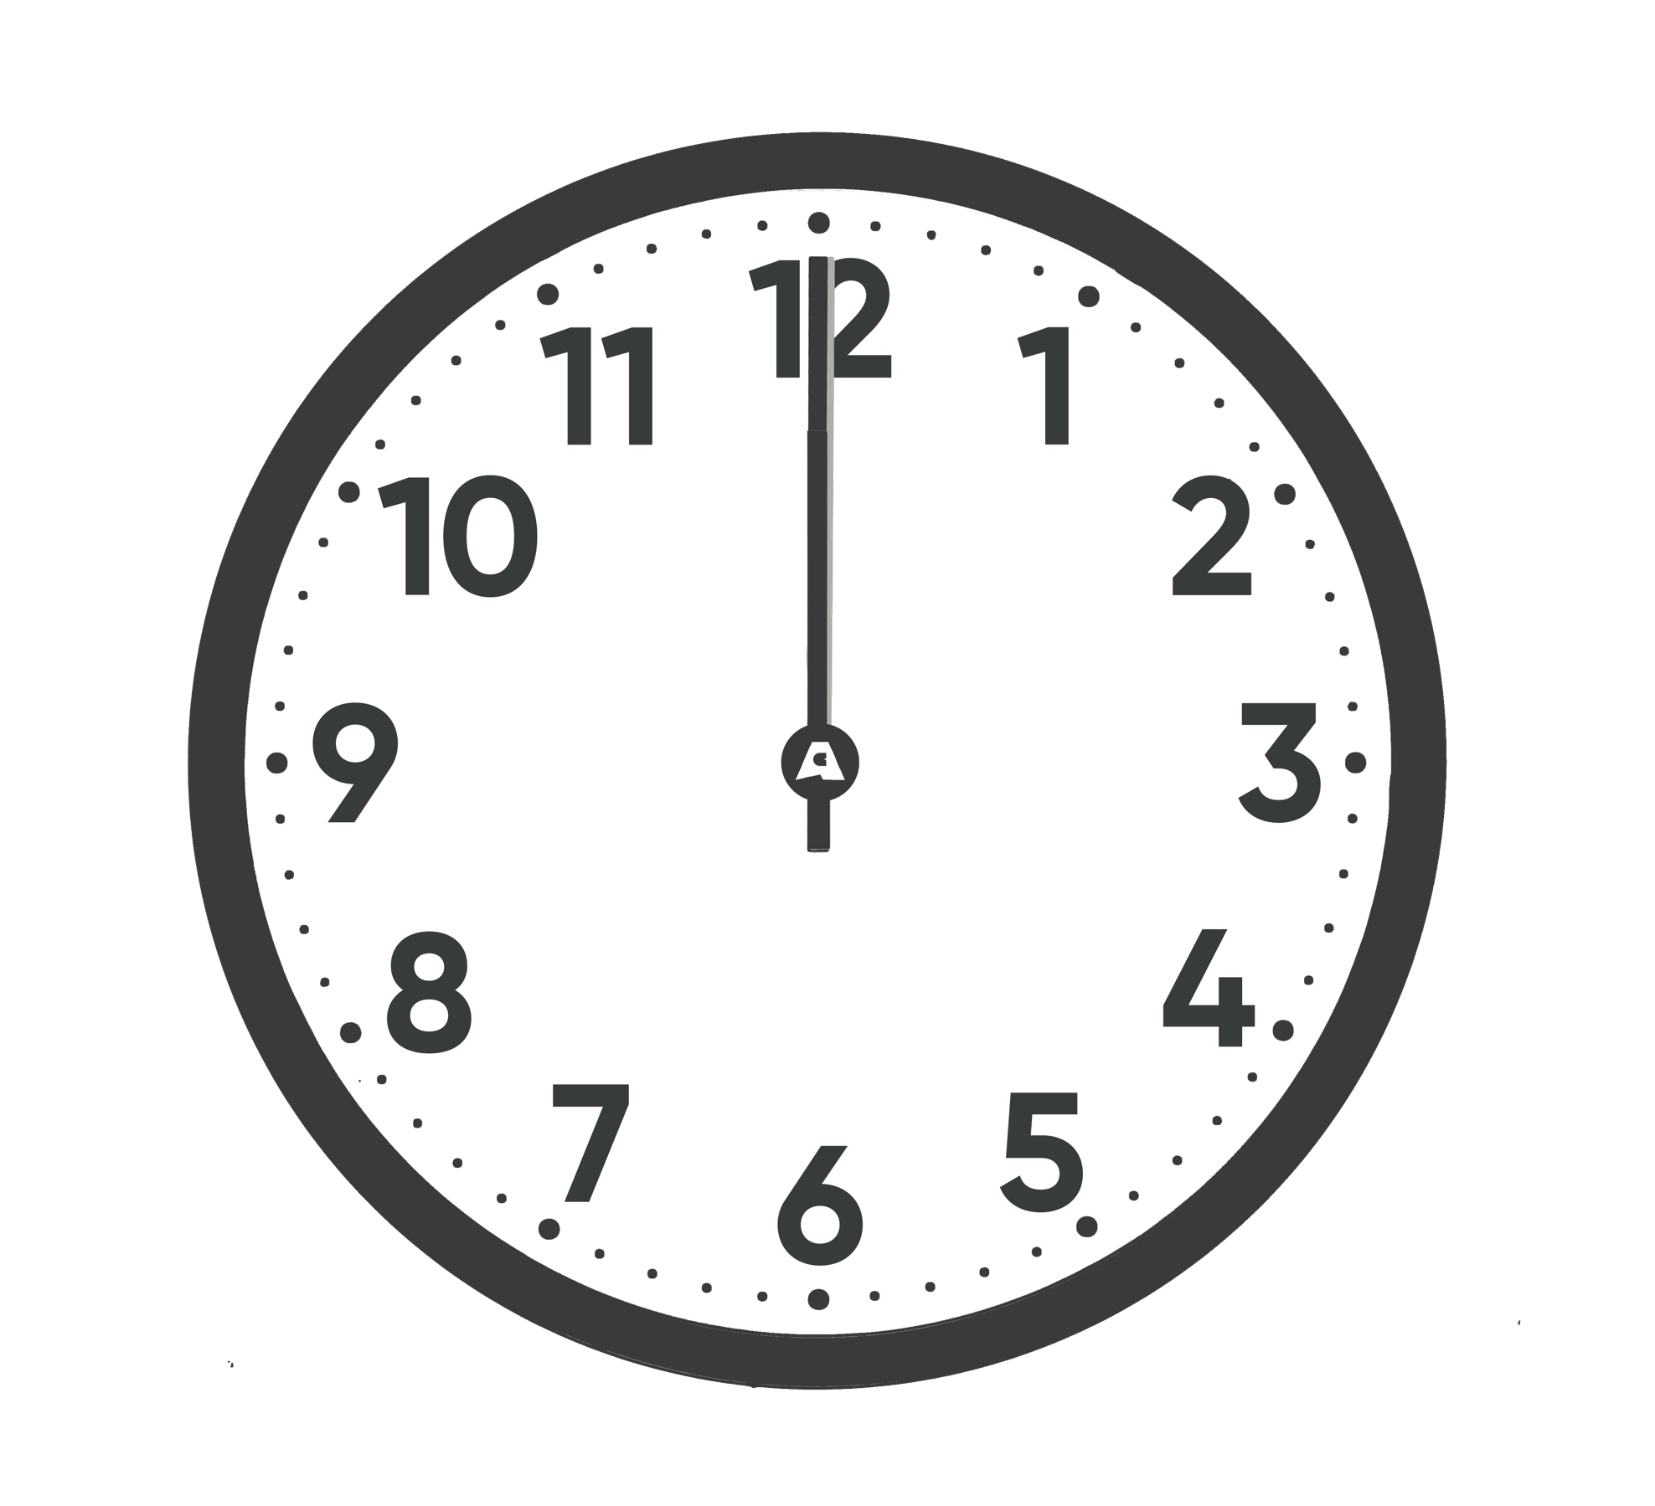  Afternoon |  | 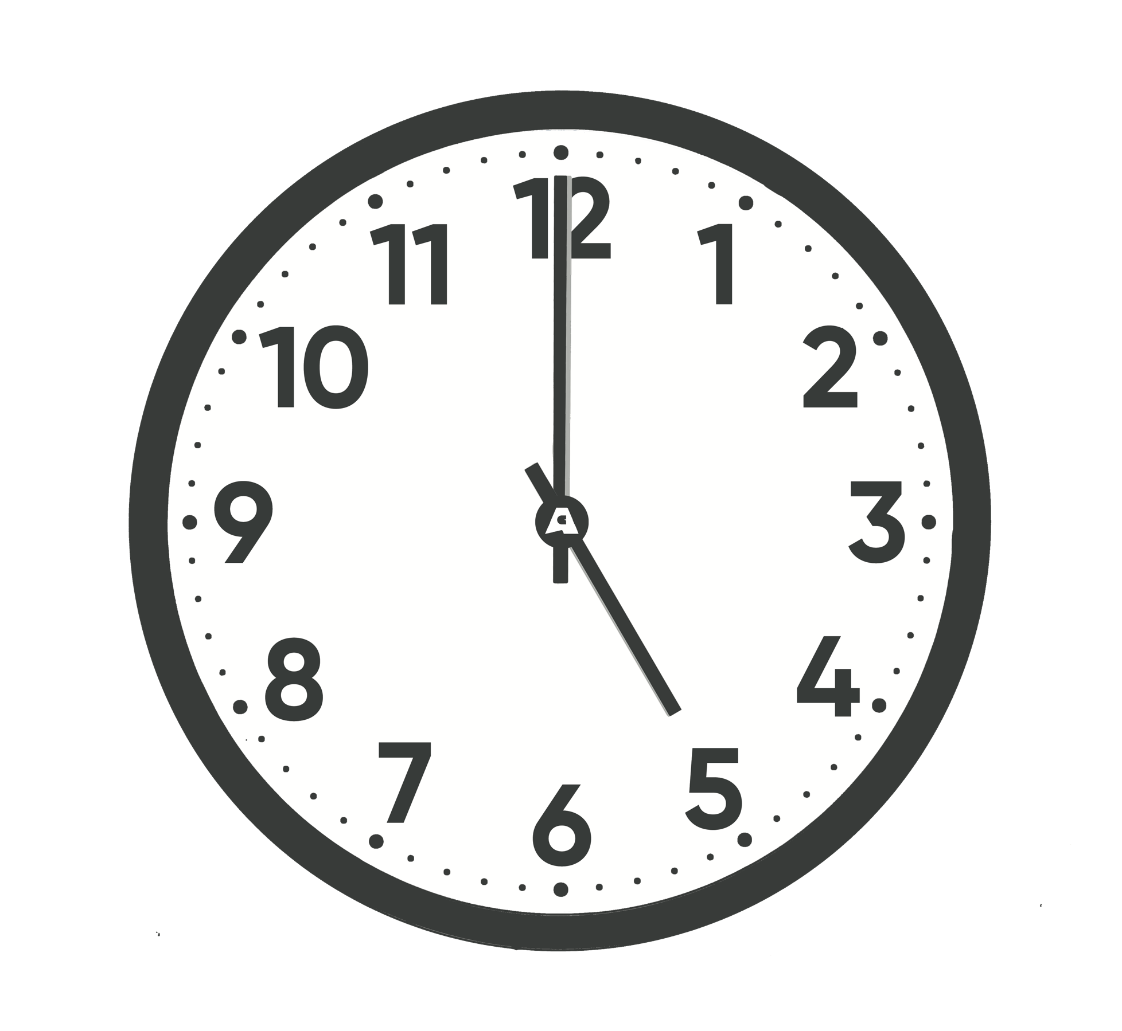  Afternoon
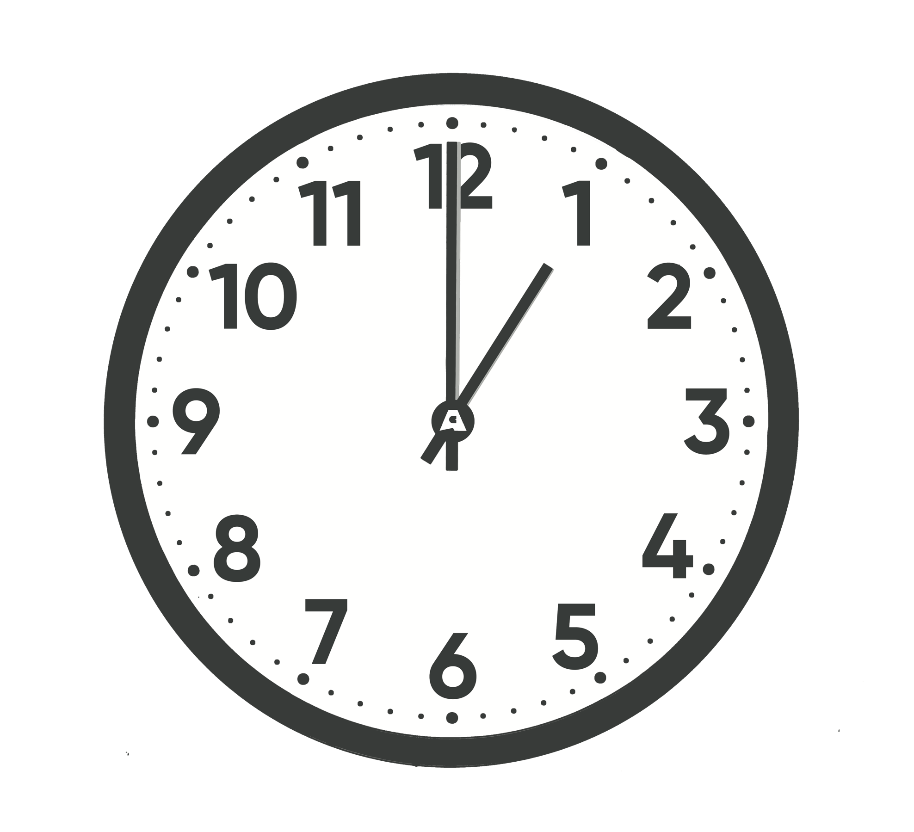  Afternoon |  | 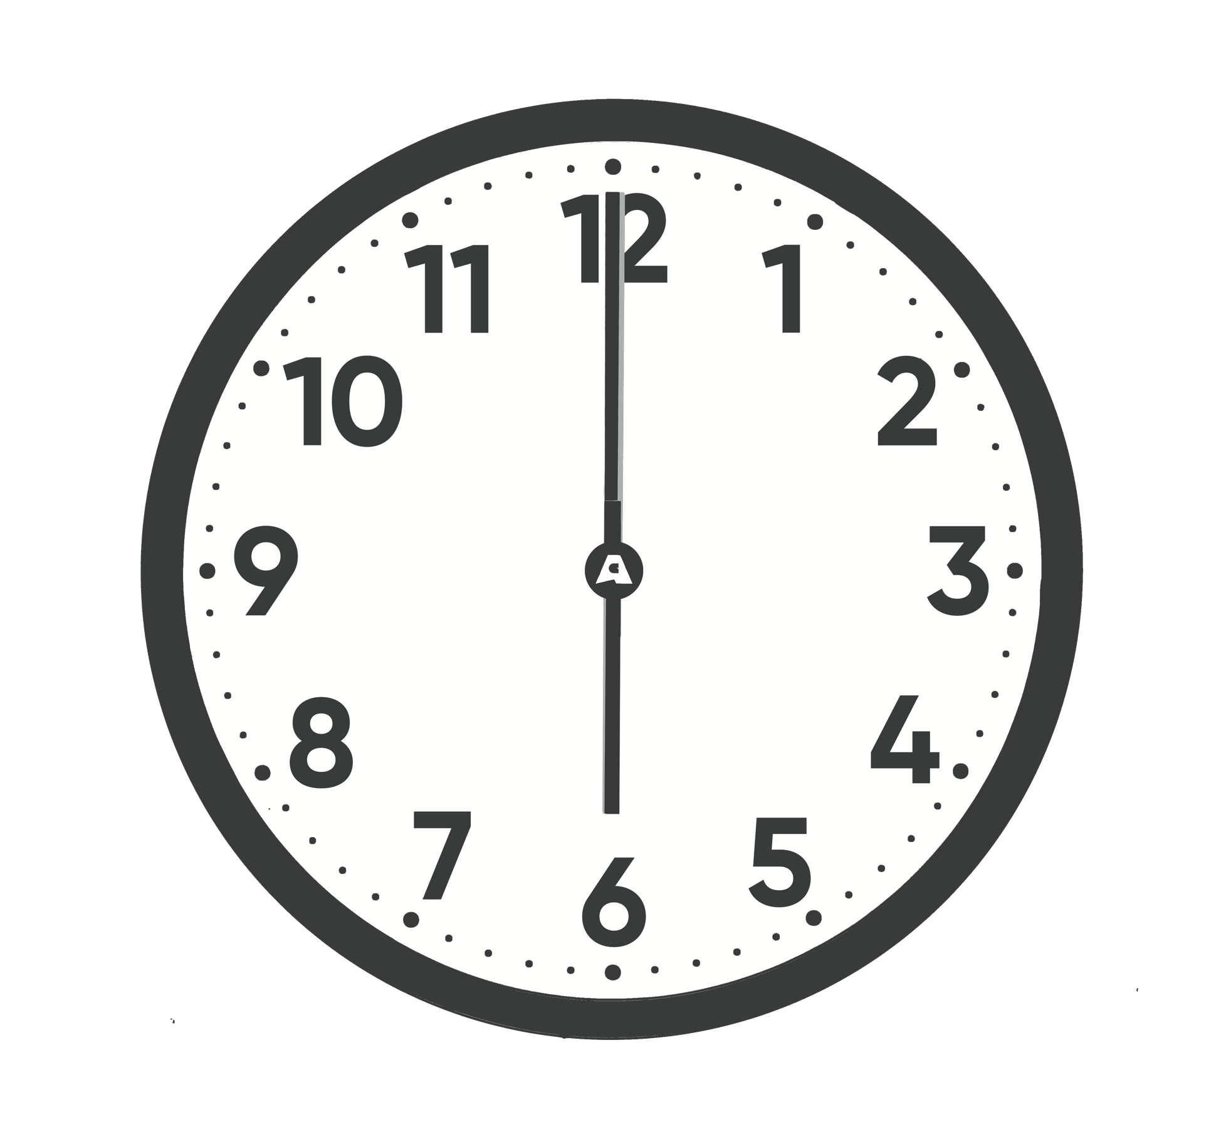  Afternoon

Getting Down with the Garage Groove!

Name: Date:

Maths: (6 – 8 years)

Task A
Person 1:

Person 2:

Person 3:

Person 4:

Task B
Person 1:

Person 2:

Person 3:

Person 4:

Person 5:

Getting Down with the Garage Groove!

Name: Date:

Science:

1.

2.

3.

4.

5.

6.

7.

8.

9.

10.

